**An Organizational Scenario**

* This is scenario of an organization called as Learning Thoughts.
* Learning Thoughts has an application for HRMS => lt-hrms [ADP, Docker_install]
* Learning Thoughts has many customers and Each of customers have their own server infrastructure. Some organizations have

On-Premise Infrastructure: 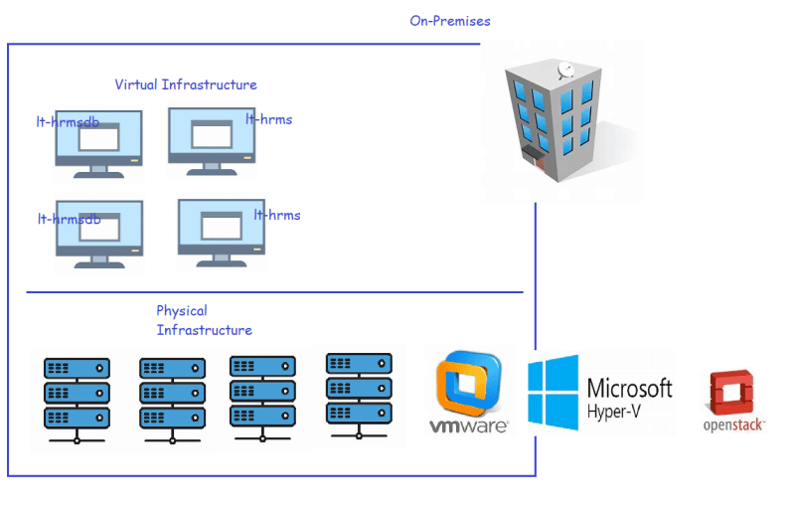

Cloud Infrastructure

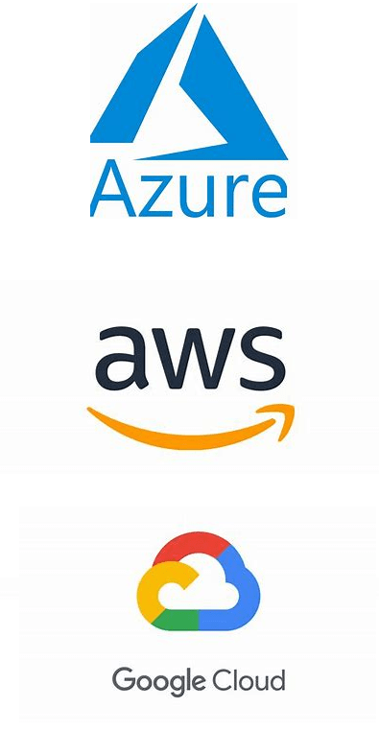

* So, how does lt-hrms handle the variations in server infrastructure
* Automating deployment for multiple server infrastructures is also a challenge
  + VMWare has its own way of automation
  + HyperV has its own ways of automation
  + OpenStack Has its own way of automation
  + Azure => Azure CLI/Powershell or ARM Templates
  + AWS => AWS CLI or CloudFormation
  + GCloud => GCloud cli or Gcloud templates
* So, we need an effective solution which can deploy lt-hrms app in multiple server infrastructure (Creating servers) and then to deploy application into individual server using shell/PowerShell/ansible/chef etc

What are possible solutions?

* + Writing a script for all the possible infrastructures might be complex and making changes will become difficult
  + Create your own tool with the help of dev team. Maintenance becomes a challenge
* To solve these kinds of issues, we need InfraProvisioning tools. We have the InfraProvisioning tools such as AWS CloudFormation, Azure ARM Template, Openstack Heat but they work only their environments
* Terraform is an infra provisioning tool which can work with various server infrastructures and the way we approach to write the template in terraform is declarative

Terraform supports Declarative Language

* Terraform is an Opensource tool developed by HashiCorp using Go Language. Terraform is all about copying one binary(executable) in the system
* 5000 feet overview of how terraform works 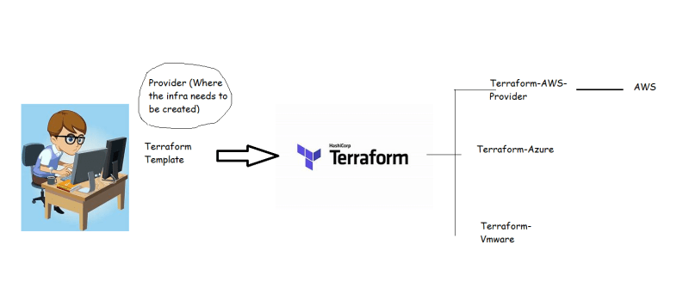

Diagram to represent terraform



Terraform Installation:

URL: <https://www.terraform.io/downloads>





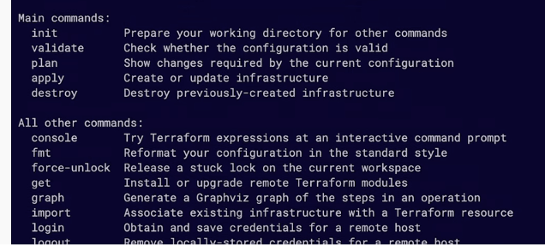

* Infrastructure as Code (IaC):
  + This means expressing our infra needs in the form of some template.
  + While creating/realizing the infra, pass the dynamic values.
* Terraform:
  + IaC which runs on any virtual platform
* What do we have to do
  + Define your infrastructure as a template in Terraform
  + Execute the template to create infrastructure.
* In which Language do we need to write these templates?
  + Hashicorp Configuration Language (HCL)
* Here we express what we want in the template which is referred as **Desired State**
* Now when execute terraform will try to create infra to match your Desired State.
* Idempotence: This is property which states that executing once or multiple times will have the same result
* For infra-provisioning we need a template which helps in meeting desired state and is idempotent.
* There are two popular tools
  + Terraform
  + Pulumi

Note: Consider docker install shell script, and how it manages to install docker in multiple environments. Immutable infrastructure: Infrastructure that we can’t modify.